**Xbox One Controller Layout For Tank Warfare Project - In Game event**

Scoreboard

Right Trigger - Accelerate

Right Bumper - Fire Main Weapon

Brake/Reverse - Left Trigger

Use Scope - Left Bumper

Pause Menu

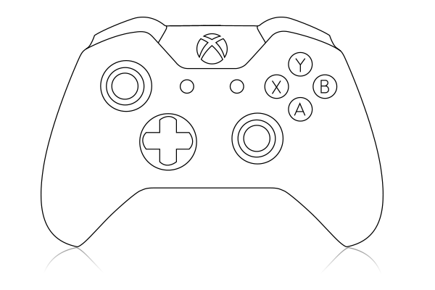

Y - Change Camera View

X - Use Ability

B - ?

A - ?

Camera View Position

Steering

Zoom Scope In - Up

Scroll Ability Wheel Right - Right

Scroll Ability Wheel Left - Left

Zoom Scope Out - Down

Using ? to determine undefined keys.

Liable to change upon second opinions.

**Keyboard Layout for Tank Warfare Project - In Game Event**

|  |  |  |
| --- | --- | --- |
| **Intention** | **Key** | **Actuator** |
| Move Forward / Accelerate | W | Tank Tracks Move Forward |
| Reverse / Brake | S | Tank Tracks Move Backwards |
| Scoreboard | Tab | Displays Scoreboard on Screen |
| Pause Menu | Esc | Pauses game and displays options |
| Turn left | A | (Greg or Jamie can provide description here.) |
| Turn Right | D | (I legit thought it was like rowing) |
| Fire Main Weapon | Left Mouse Button | Main Cannon Shoots Missile |
| Look Left | Move Mouse Left | Camera changes Yaw position to minus figures |
| Look Right | Move Mouse Right | Camera changes Yaw position to plus figures |
| Look Down | Move Mouse Down | Camera changes Pitch position to minus figures |
| Look Up | Move Mouse Up | Camera changes Pitch position to plus figures |
| Change Camera View | V | Moves camera position to another position on tank. (E.g. front end of tank, top of tank, slightly further off the tank etc.) |
|  |  |  |
|  |  |  |
|  |  |  |
|  |  |  |

**Xbox One Controller Layout For Tank Warfare Project - In Menu**



Y - ?

X - ?

B - Back

A - Select

Above Option - Up

Option to the Right - Right

Option to the Left - Left

Below Option - Down

Above Option - Up

Option to the Right - Right

Option to the Left - Left

Below Option - Down

Using ? to determine undefined keys.

Liable to change upon second opinions.

**Keyboard Layout for Tank Warfare Project - In Menu**

|  |  |  |
| --- | --- | --- |
| **Intention** | **Key** | **Actuator** |
| Move Cursor to option above current option. (If at top of options, move cursor to bottom option) | Up Arrow Key | Cursor appears on above option |
| Move Cursor to option below current option. (If at bottom of options, move cursor to top option) | Down Arrow Key | Cursor appears on below option |
| Go back a menu | ESC | Goes to parent directory |
| Select option | Return | Selects option |
|  |  |  |
|  |  |  |
|  |  |  |
|  |  |  |
|  |  |  |
|  |  |  |
|  |  |  |
|  |  |  |
|  |  |  |
|  |  |  |
|  |  |  |
|  |  |  |